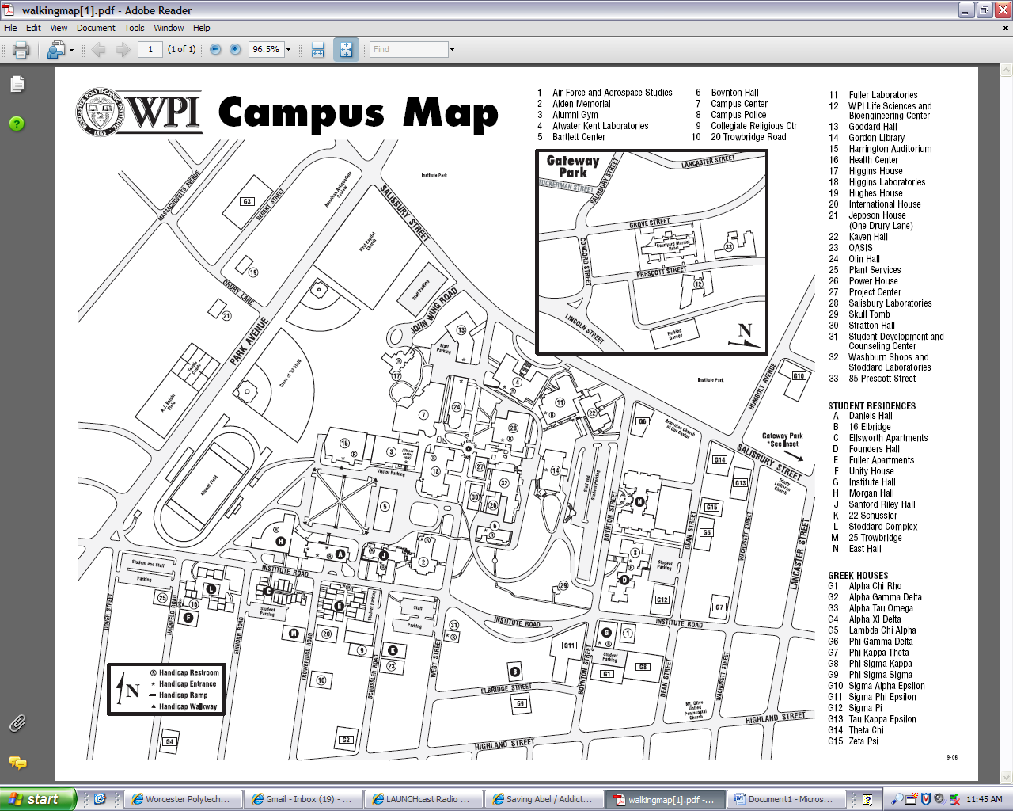

P

P

Buildings used

Designated Parking lot – off John Wing Rd

*Alternate parking may be availble in the West Street lot*